**Lesson 11 Cíntia Domingos**

**Level 1**

**1.** Answer B: all the transitions shown in the chart are covered by the test cases in the table.

**2.** Answer D. Condition 1 = NO, Condition 2 = YES, Condition 3 = NO, Action = NO: employees with less than 1 year of experience also get goals assigned, but they may not achieve them and don’t get bonuses.

**Level 2**

**2.**

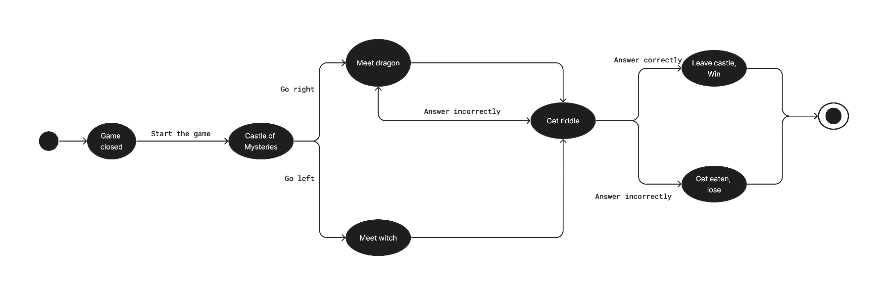<https://www.figma.com/file/qlk4KHmZ50CH6Ls2nKzRAE/>

**3.** 5 test cases:

1. Witch -> correct answer -> win

2. Witch -> incorrect answer -> dragon -> correct answer -> win

3. Witch -> incorrect answer -> dragon -> incorrect answer -> correct answer -> win

4. Witch -> incorrect answer -> dragon -> incorrect answer -> incorrect answer -> lose

5. Dragon -> correct answer -> win

The path if the user goes right, to the dragon, and answers incorrectly is already covered by the third and fourth test cases.

**Level 3**

**2a.**

|  |  |
| --- | --- |
| **Use Case ID** | 1.00 |
| **Use Case ID Name** | Create account |
| **Use Case Description** | User can create a new account using an e-mail address |
| **Actor** | App user |
| **Precondition** | Device is connected to the Internet.  User has an e-mail address.  User has the app installed. |
| **Postcondition** | After successfully creating an account, a confirmation e-mail is sent to the provided user e-mail. |
| **Basic Flow** | 1. The user inserts a valid e-mail address in the field “E-mail address” (such as example@example.com) on the “Create account” page.  2. The user inserts a valid username in the field “Username” (up to 15 characters, only letters and/or numbers) on the “Create account” page.  3. The user inserts a valid password in the field “Password” on the “Create account” page (8-20 characters, at least one upper case, one lower case, one number and one special character).  4. The system validates the inserted data.  5. The system creates the user account.  6. The system sends a confirmation e-mail to the provided e-mail address. |
| **Extensions** | 4a. The e-mail address is not in the valid format. The system displays the message “This is not a valid e-mail address. Insert a valid e-mail address such as example@example.com”.  4b. The username contains special characters. The system displays the message “The username must only contain letters and/or numbers.”.  4c. The password does not have 8-20 characters, at least one upper case, one lower case, one number and one special character. The system displays the message “Insert a password with 8-20 characters, at least one upper case, one lower case, one number and one special character.”.  4d. If the provided e-mail address already belongs to an account, system displays the message “An account with this e-mail address already exists.”.  4e. If the provided username is already taken, the systems displays the message “That username is taken. Choose another one.”. |

|  |  |
| --- | --- |
| **Use Case ID** | 2.00 |
| **Use Case ID Name** | Login |
| **Use Case Description** | The user logs into the system to access its functionalities |
| **Actor** | App user |
| **Precondition** | Device is connected to the Internet.  User has the app installed.  User has an account. |
| **Postcondition** | After a successful login, the user has access to the functionalities of the app. |
| **Basic Flow** | 1. The user enters the username and password.  2. The system validates the credentials.  3. The system allows the user access to their account |
| **Extensions** | 2a. The user inserts an invalid username. The system displays the message “Username and/or password incorrect.”.  2b. The user inserts an incorrect password. The system displays the message “Username and/or password incorrect.”. |

|  |  |
| --- | --- |
| **Use Case ID** | 3.00 |
| **Use Case ID Name** | Upload picture |
| **Use Case Description** | The user can upload pictures to the user profile |
| **Actor** | App user |
| **Precondition** | The user is logged in and on the user profile page. |
| **Postcondition** | A picture is added to the user profile. |
| **Basic Flow** | 1. The user clicks on the button “Upload picture”.  2. The user selects a picture from the device to upload it.  3. The system validates the picture for the supported extension (JPG, PNG), size (up to 5 MB) and resolution (180x180 up to 1080x1080 px).  4. The system uploads the picture to the app. |
| **Extensions** | 3a. The file is not in a supported extension (JPG, PNG). The system displays the message "Please select file in JPG or PNG format.”.  3b. The file size is more than 5 MB. The system displays the message “Please select a file with size up to 5 MB.”.  3c. The file resolution is not between 180x180 and 1080x1080. The system displays the message “Please select a file with resolution between 180x180 and 1080x1080.”. |

|  |  |
| --- | --- |
| **Use Case ID** | 4.00 |
| **Use Case ID Name** | Comment on a picture |
| **Use Case Description** | The user can add comments to the pictures |
| **Actor** | App user |
| **Precondition** | The user is logged in and has at least 1 uploaded picture or 1 friend with 1 uploaded picture. The user is on the page of the picture. |
| **Postcondition** | A comment is added to the picture. |
| **Basic Flow** | 1. The user types a comment in the comment box.  2. The system validates the comment (2 – 500 characters).  3. The comment is added under the picture. |
| **Extensions** | 2a. The comment has less than 2 or more than 500 characters. The system displays the message “Insert a comment with 2 – 500 characters.” |

|  |  |
| --- | --- |
| **Use Case ID** | 5.00 |
| **Use Case ID Name** | Add a friend |
| **Use Case Description** | The user can add another user as a friend to receive updates on their cat photos |
| **Actor** | App user |
| **Precondition** | The user is logged into the app. |
| **Postcondition** | The user has a friend added to their profile and receives updates when they add new pictures. |
| **Basic Flow** | 1. The user searches for another user using the search field in the header.  2. The system returns the results matching the search performed.  3. The user selects the desired user profile and taps on the button “Add friend”.  4. The other user accepts the invitation.  5. The system registers the connection between the profiles. |
| **Extensions** | 2a. The system returns no results and displays the message “No results found. Try a different search.”.  4a. The other user rejects the invitation. The connection between the profiles is not registered. |

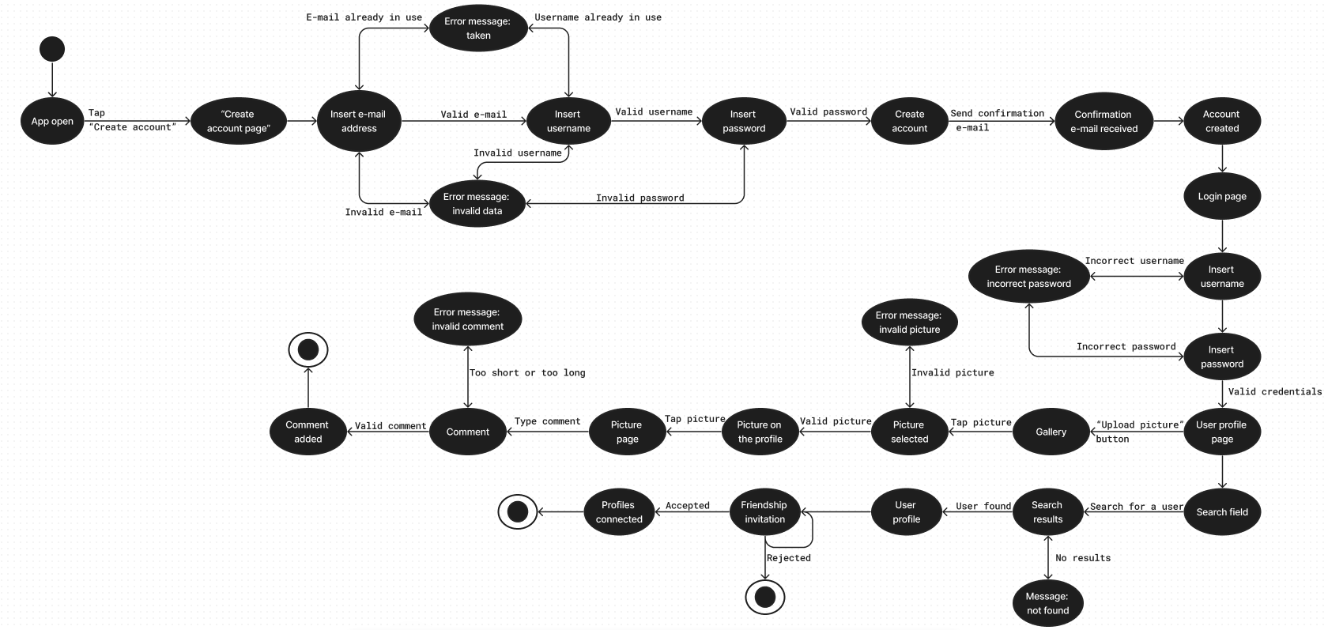**b.** <https://www.figma.com/file/ULIhsh6RoNoBS9ZtrRDrjb>

**Decision table for account creation (TC1)**

|  |  |  |  |  |  |  |  |  |
| --- | --- | --- | --- | --- | --- | --- | --- | --- |
| Conditions/Tests | Test 1 | Test 2 | Test 3 | Test 4 | Test 5 | Test 6 | Test 7 | Test 8 |
| E-mail address (T/F) | T | T | T | T | F | F | F | F |
| Username (T/F) | T | T | F | F | F | F | T | T |
| Password (T/F) | T | F | T | F | F | T | F | T |
| Expected result | A | E | E | E | E | E | E | E |

**A – account created**

**E – error message**